**Spatial Relationship between Environmental Justice and Tier II Facilities in Massachusetts**

Chengming Zhou [CheZhou@clarku.edu](mailto:CheZhou@clarku.edu)

Mina Wei [MiWei@clarku.edu](mailto:MiWei@clarku.edu)

**Abstract**: This study explored the aggregation of environmental justice populations through the standardized SVI indicator (Social Vulnerability Index), and vulnerable populations have similar areas of aggregation through the aggregation analysis of the cluster map of SVI. After using spatial analysis to examine the spatial geographic location of secondary facilities and environmental justice community areas, we found significant similarities and overlaps between the two regions related to gentrification policies.

1. Introduction

This study wanted to understand the relationship between the Social Vulnerability Index (SVI) and environmental justice zones. The aggregation of environmental justice populations is explored through a standardized SVI indicator. The SVI is a comprehensive composite index that combines several critical components of selected social vulnerability indicator variables. The SVI groups include socioeconomic status: below the poverty line, unemployed, low income, and no high school diploma. And family composition and disability: 65 years or older, 17 years or younger, civilians with disabilities, and single-parent households. And minority status and language: including minority, five years old or older, and who speak English "not very well" and housing type and transportation: multi-unit structures, mobile homes, crowded, no transportation, and group homes.

It is obtained by performing a principal components analysis on several selected SVI variables by linearly combining several main components, which quantifies the relative level of overall social vulnerability. Geospatial correlations between environmental justice areas and secondary facilities in Massachusetts were studied. A secondary facility stores hazardous chemicals in more than a certain quantity. The population of environmental justice areas is relatively vulnerable in society and consists of low-income, minority, and English as a second language. Because of their socially invisible status, their rights may be unknowingly violated. To examine whether society tends to place sources of pollution near socially disadvantaged groups. This study wanted to determine if society tends to locate pollution sources near socially disadvantaged groups. And what environmental pollution people receive in environmental justice areas. The potential negative impacts on climate justice groups are explored by showing the spatial relationship of secondary facilities. We can use past data, studies, and field surveys to analyze the affected groups.

Maantay (2006) summarized the application of GIS spatial analysis in assessing environmental health and equity. In this article, the authors examine the results of maps of environmental justice issues and point out their limitations. The authors propose a series of measures to address these issues, such as improving the database and developing relevant risk indicators.

Lees et al. (2008) describe gentrification in detail as transforming poor or otherwise unattractive neighborhoods by making space for the entry of more affluent people and businesses. This form of urban planning increases the economic value by efficiently using its resources. But it can also cause social injustice, such as displacement and further segregation of various populations.

Wilson et al. (2010) examined whether areas where vulnerable populations, including people of color, congregate because of climate change expose them to higher levels of social and environmental harm. The authors use local cluster analysis to show the location of contiguous areas with similar vulnerabilities, visualizing the vulnerability index as a spatial index.

Kedron (2016) identifies the spatial extent of clusters around a pre-defined site of interest from available empirical evidence using local Moran's I statistics. Combining containment buffers with traditional local Moran's I techniques, this approach identifies clusters as an alternative to commonly used containment buffers.

Park et al. (2022) discussed the differential contributions of the constituent components of the SVI. Using geographically weighted principal components analysis, they investigated how local indicator variables evolved over time and across the more fantastic Houston, USA, metropolitan area. It found that high social vulnerability in suburban areas was highly correlated with the percentage of mobile homes. It also finds that indicator variables of social vulnerability exhibit substantial spatial heterogeneity and dependence at the local scale.

1. Data

SVI data from the Agency of Toxic Substances and Disease Registry. It is a statistical excel table containing SVI data for each city in Massachusetts in 2018.

Climate justice population maps were obtained from MassGIS (the state's one-stop shop for interactive maps and related descriptive information). We used 2019 environmental justice population data. The map is in shp. Format.

The Massachusetts Executive Office of Energy and Environmental Affairs provided information on the Tier II facility characteristics. The Massachusetts 2020 Tier II Facility Characterization Map contains the locations where individual facilities are, and the files are in shapefiles for download.

1. Methodology (Figure 1)

Two GIS analysis tools were used in the project: GeoDa was primarily used to analyze the spatial relationship analysis associated with SVI, while ArcGIS Pro was used for the spatial analysis process for Tier II Facilities.

As mentioned above, SVI is not a known fixed value but needs to be calculated by the researcher by picking different variables for the personal requirement. We standardize all 15 variables under the four broad indicators, 14 of which use the following formula:

Standardized value (SV) = range width × (raw value – min value) / (max value – min value)

And for the variable Per Capita Income, we need to modify the formula to reverse the values - the most vulnerable are tracts with smaller values. The standardized calculated values were averaged in four categories according to different indicators.

We import the processed polygon features into GeoDa, click on "Weights Manager," select Distance-Band Spatial Weights, and use the system defaults for the specific parameters to create a particular gwt file. After clicking on the single-variable local Moran's I, select the four aggregated SVIs as variables to display their Cluster Map and Moran Scatter Plot, respectively. In Moran Scatter Plot, a linear fit is performed to the point cloud with a slope corresponding to Moran's I (at the top of the Scatter Plot). In Cluster Map, we mainly observe the area where the dark red color (high-high cluster) is located, i.e., which represents the high feature area surrounded by high neighbors (Anselin, 2020).

Since the distribution of the point features (Tier II Facilities) is more dispersed, we use the Optimized Outlier Analysis tool (Robust -999 permutations) and the Optimized Hot Spot Analysis tool in the spatial statistics toolbox; these two tools can automatically generate a suitable grid for the point features. The maps presented by the Optimized Outlier Analysis can distinguish between high value (HH) clusters with statistical significance, low value (LL) clusters, high-value outliers surrounded mainly by low values (HL), and low-value outliers surrounded primarily by high values (LH), with the confidence level of statistical significance set at 95%. The Optimized Hotspot Analysis tool validates statistically significant hotspots, where elements should have high values and be surrounded by other factors with high values. Default values are used for the above tool parameters.

1. Result
   1. SVI

We made four scatter plots (Figure 2-5 ) and four cluster maps (Figure 6-9 ) based on the four indicators, respectively. Moran's I is statistically significant because it is positively correlated when Moran's I is greater than zero, indicating that objects with similar attributes are clustered together. From the cluster maps, those with Minority Status & Language (Figure 8) as indicators show the most apparent clustering trend. Areas close to larger cities (Boston, Springfield) show high clustering (dark red), while large areas of low clustering exist away from cities. This may be due to ethnic clustering, where the same ethnicity prefers to form a community. Local communities would be more likely to attract the same ethnic population in such an environment. They may be less likely to use the official language (English) and adopt the native language for daily communication. It seems that the socially susceptible population is more dispersed from the Household composition & Disability indicator (Figure 7) because these variables (age >65, age <17, disability, and single-parent households) are more generalized, and political or economic factors do not easily influence it. The remaining two indicators (Socioeconomic Status, Figure 6, and Housing Type & Transportation, Figure 9) are based on the economy. Because of the need for money, the group may gravitate to cities with more job opportunities.

* 1. Tier II Facilities

The kernel density map (refer to Map 1) gives the most intuitive density distribution of Tier II facilities. The concentration of facilities in major cities in Massachusetts, including Boston, Springfield, Worcester, Lowell, Barnstable, etc., can be seen based on the color depth centers. Since Boston is the capital city, large companies usually choose to build their plants here, so the density of Tier II facilities is the highest.

In the cluster map (refer to Map 2), Boston shows a similar trend to the density map, with very high HH aggregation. Other cities, except Springfield, which has some areas with HH aggregation, offer no significance.

From the Hot Spot map (refer to Map 3), 99% confidence regions account for most hotspots, with statistically significant hotspots concentrated in the Boston region, followed by Springfield and Worcester. Finally, a small number of 90% confidence hotspots exist in Barnstable.

1. Discussion

It can only be considered a preliminary model for the calculation of SVI because we have selected only some of the variables and divided them roughly into several broad categories to facilitate the analysis. If the individual variables are analyzed spatially, it may be possible to obtain a clearer cluster trend and see the pattern of change more quickly.

As the map shows, both density and aggregation are concentrated in large cities, overlapping with the Environmental Justice Group map (refer to Map 4). A significant limitation of this analysis is that it does not consider population suburbanization. In large US cities, including Boston, the wealthy have gradually begun to migrate to the urban periphery rather than choosing to congregate in downtowns. This trend appears to be a conscious effort to squeeze out environmentally vulnerable populations to live in a way that forces them to relocate. Therefore, the time comparison will be an essential reference factor, and future studies can be developed in this direction.

1. Conclusion

From the SVI cluster map, the socioeconomic, minority, and housing type & transportation indicators show high regional clustering centered on Boston and Springfield, which is similar to the complexity of climate-sensitive populations in these two urban areas as expressed in the Environmental Justice Group Map (refer to Figure 4) provided by MassGIS.

From the different spatial analysis patterns (kernel density, outliers, hotspots), universal conclusions can be drawn, again in the Boston and Springfield neighborhoods, where high values of either density or matter statistical significance exist, indicating that Tier II Facilities are heavily clustered in these areas. In addition, high confidence hotspots are also present in the Worcester neighborhood. The clustering is more in line with the environmental justice cluster map, where pollution sources are more likely to cluster in areas where climate-sensitive populations live. This trend may involve political or economic factors.

Appendix: Figure

Figure 1: Flowchart of Process

Figure 2: Moran Scattle Plot of Socioeconomic Status

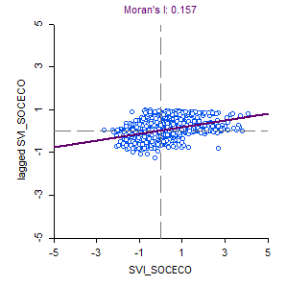

Figure 3: Moran Scattle Plot of Household Composition & Disability

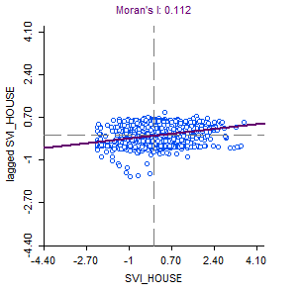

Figure 4: Moran Scattle Plot of Minority Status & Language

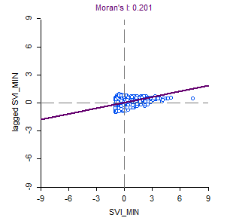

Figure 5: Moran Scattle Plot of Housing Type & Transportation

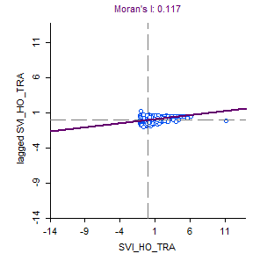

Figure 6: Cluster Map of Socioeconomic Status

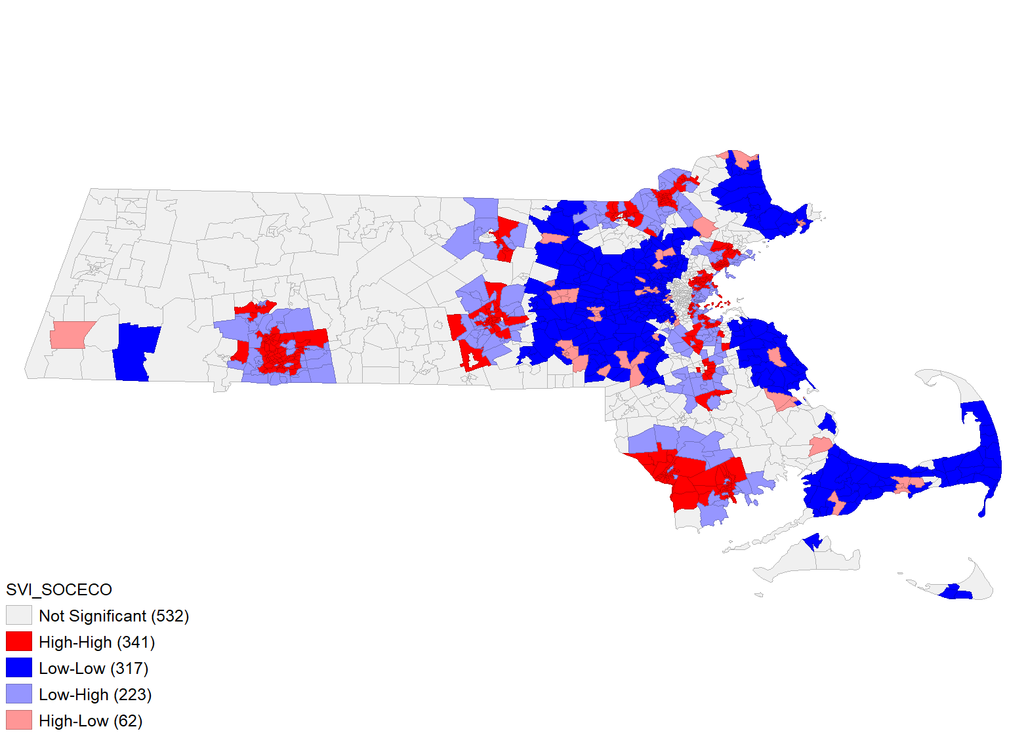

Figure 7: Cluster Map of Household Composition & Disability

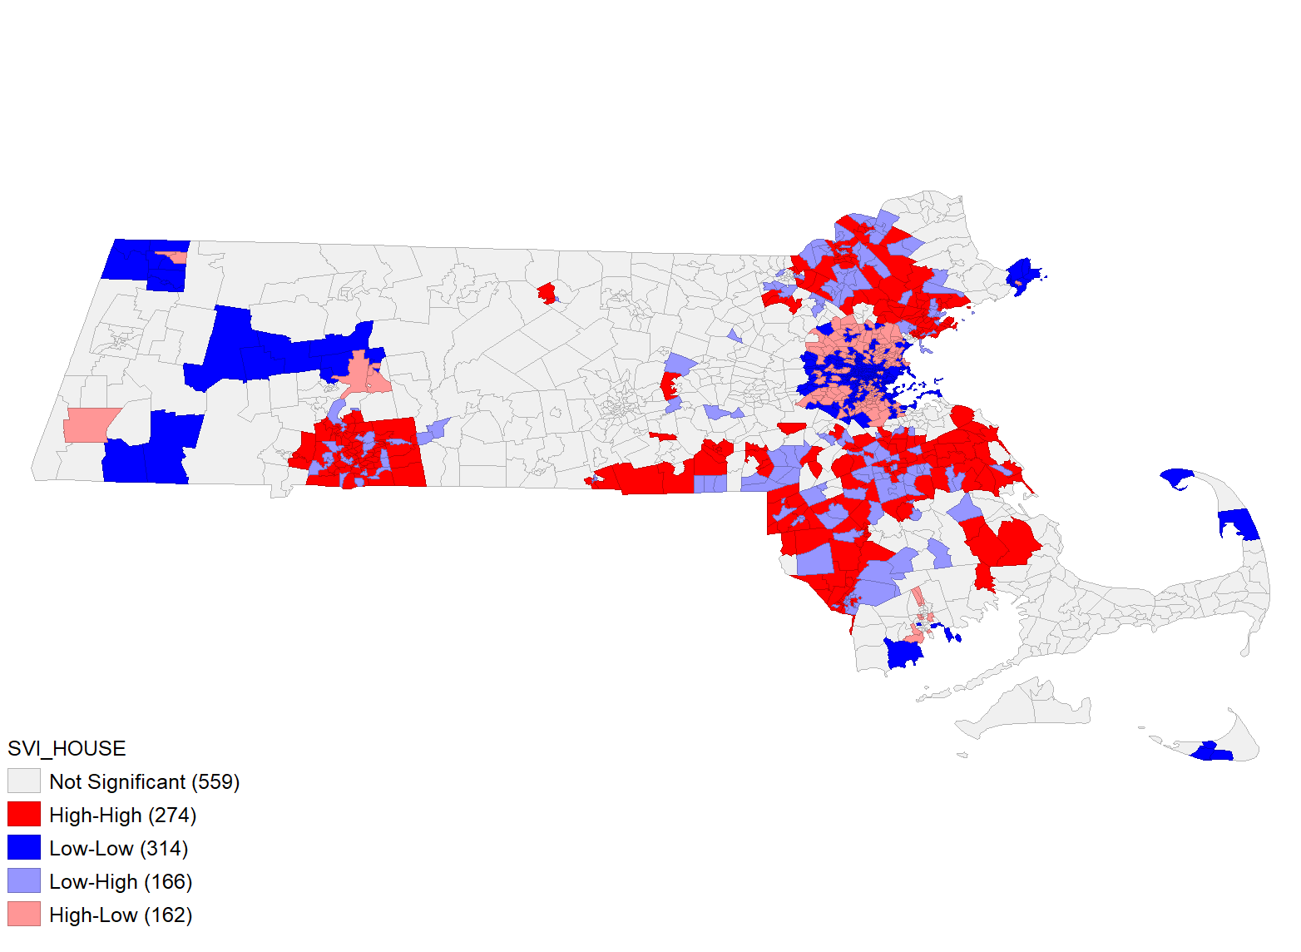

Figure 8: Cluster Map of Minority Status & Language

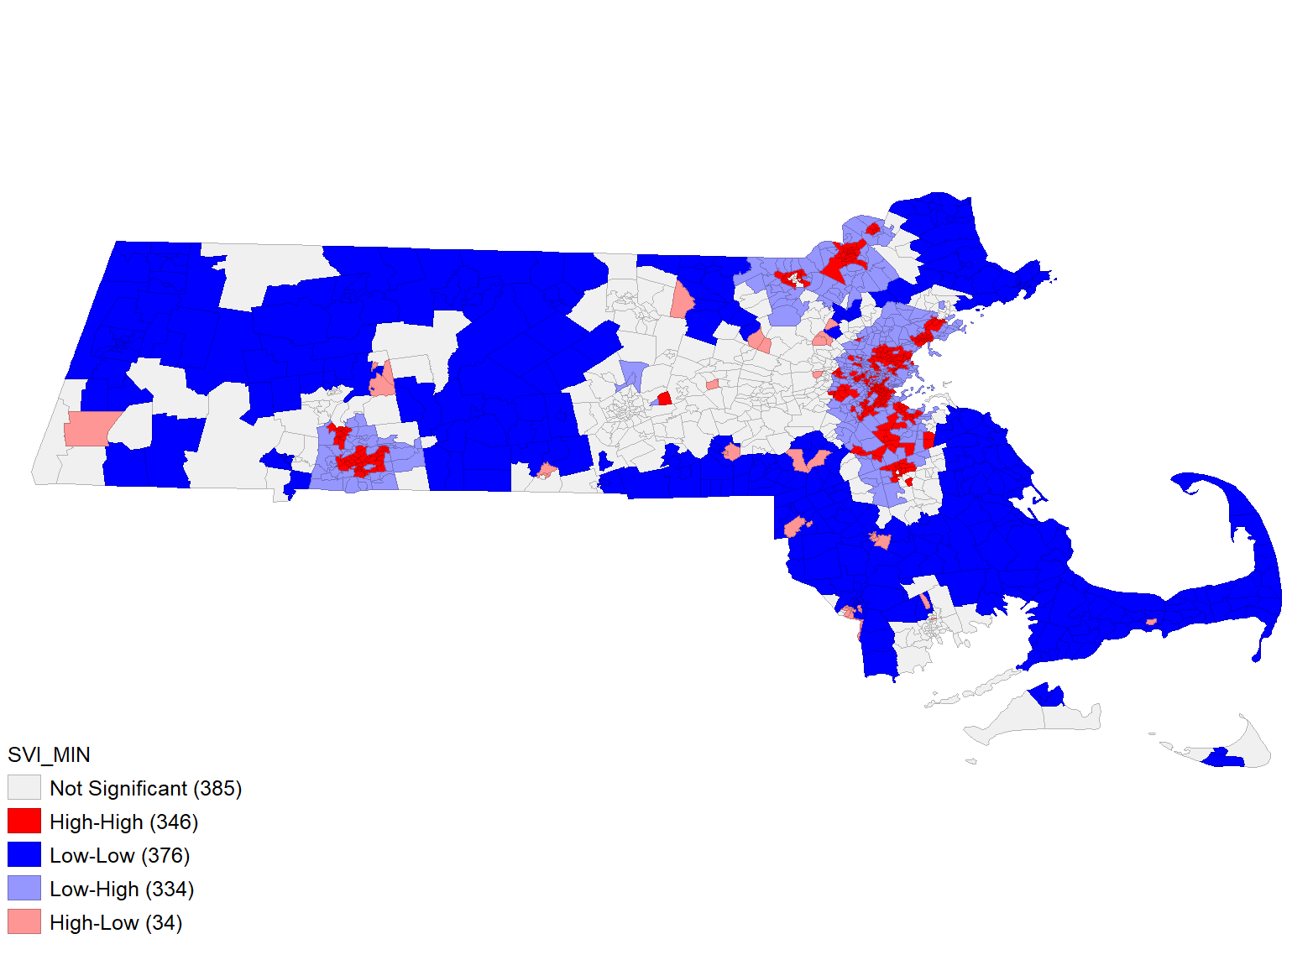

Figure 9: Cluster Map of Housing Type & Transportation

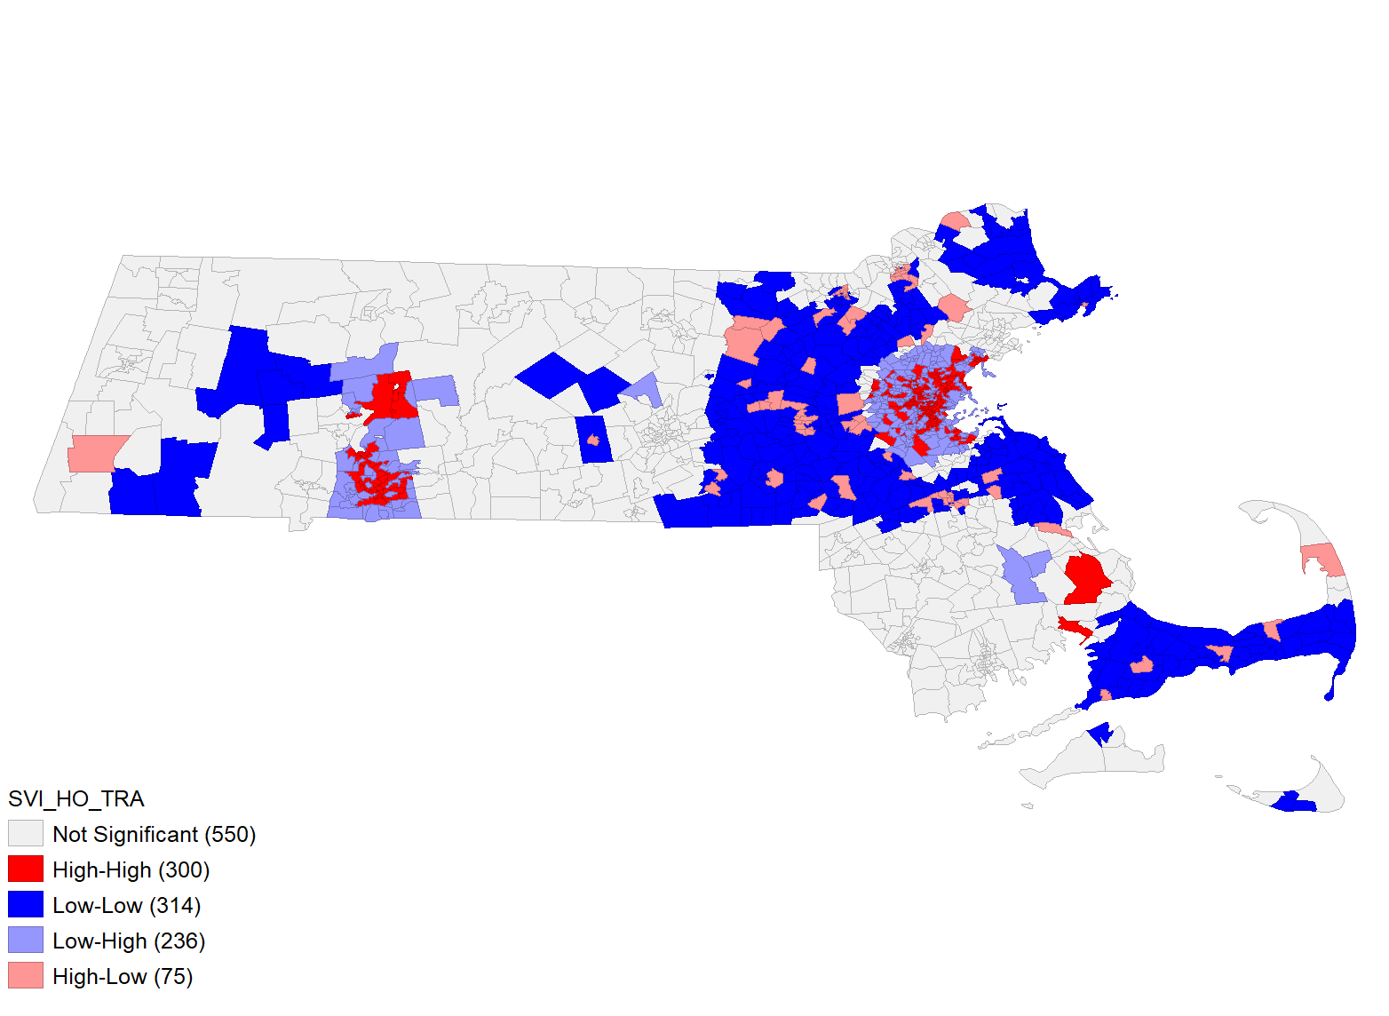

Reference

Anselin, L. (2020). Local Spatial Autocorrelation. https://geodacenter.github.io/workbook/6a_local_auto/lab6a.html

Kedron, P. (2016). Identifying the geographic extent of environmental inequalities: Comparing pattern detection methods. Canadian Geographer, 60(4), 479–492. <https://doi.org/10.1111/cag.12297>

Lees, L., Slater, T., & Wyly, E. K. (2008). Gentrification. Routledge.

Maantay, J. (2002). Mapping Environmental Injustices: Pitfalls and Potential of Geographic Information Systems in Assessing Environmental Health and Equity. Environmental Health Perspectives, 110, 161–171.

Park, G., & Xu, Z. (2022). The constituent components and local indicator variables of the social vulnerability index. Natural Hazards, 110(1), 95. <https://doi.org/10.1007/s11069-021-04938-9>

Wilson, S. M., Richard, R., Joseph, L., & Williams, E. (2010). Climate Change, Environmental Justice, and Vulnerability: An Exploratory Spatial Analysis. Environmental Justice (19394071), 3(1), 13–19. <https://doi.org/10.1089/env.2009.0035>

**Team Effort**

Mina Wei focused on literature review, data collection, and presentation, while Chengming Zhou focused on data processing and analysis of Geoda and overall data cleaning and analysis of limitations.